Lab 03: Assignment: Ping Utility Analysis
Submission by : Ankit Singh
2201AI47

1. Ping Basics
- Explain the purpose of the ping utility and its basic syntax.
The ping utility is a network diagnostic tool used to test the reachability of a host on an IP network. It measures the round-trip time for messages sent from the source to a destination and back. The primary purpose of ping is to check if a network device is reachable and how long it takes for a message to travel to the device and back.
The basic syntax of the ping command is:
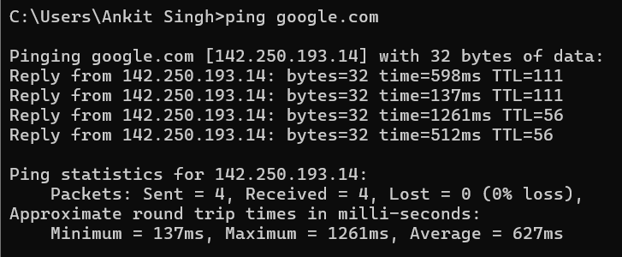

- Provide examples of how to use ping to test connectivity to a website and a local host.
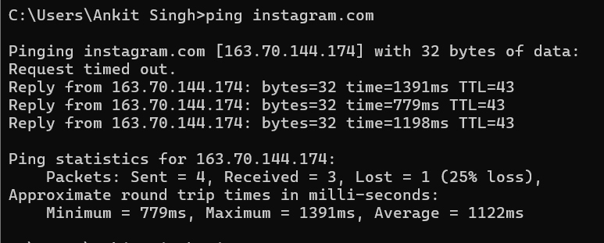

Local HOST PING
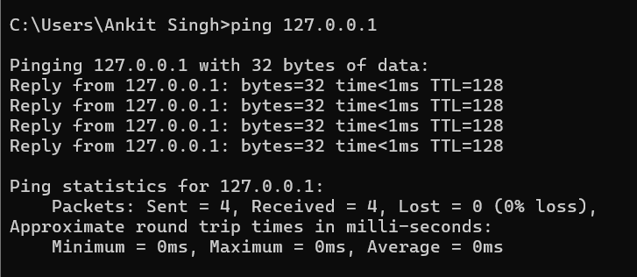

2. Ping Output Analysis
- Run the command ping (link unavailable) and capture the output.
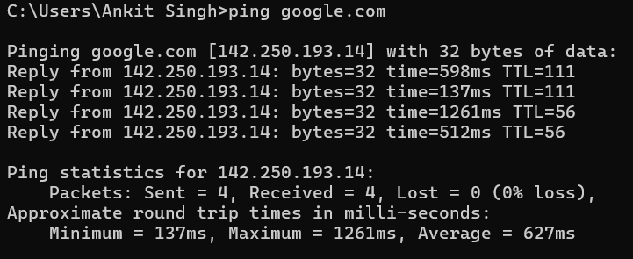
- Analyse the output, explaining each line and its significance (e.g., packet loss, round-trip time, etc.).

Output Analysis:
- PING Header: This shows the domain name, resolved IP address, and the packet size being sent.
Pinging google.com [142.250.193.14] with 32 bytes of data:
- google.com: The domain name that you are trying to reach.
- [142.250.193.14]: The IP address that google.com resolves to. Your computer uses this IP address to communicate with Google's servers.
- 32 bytes of data: Each ping request is sending 32 bytes of data. This is the size of the ICMP (Internet Control Message Protocol) packet payload.
Each of these lines represents the response received from the destination server after sending a ping request.
- Reply from 142.250.193.14: Indicates that a response was received from the IP address 142.250.193.14.
- bytes=32: Confirms that the response contained 32 bytes of data, the same as what was sent.
- time=598ms (or 137ms, 1261ms, 512ms): This is the round-trip time (RTT) in milliseconds. It measures how long it took for the packet to travel from your computer to the destination server and back. The variation in times (598ms, 137ms, 1261ms, 512ms) indicates inconsistent network latency.
- TTL=111 (or TTL=56): Time-To-Live is a value that determines the maximum number of hops (i.e., routers or other network devices) that the packet can pass through before being discarded. A higher TTL typically means the packet didn't travel through many network devices. In this case, two different TTL values (111 and 56) suggest that the packets may have taken different paths, or there could be some network configuration affecting the TTL.
Ping statistics for 142.250.193.14:
Packets: Sent = 4, Received = 4, Lost = 0 (0% loss),
- Packets: Sent = 4: Indicates that 4 ping requests were sent.
- Received = 4: Indicates that all 4 ping requests received a response.
- Lost = 0 (0% loss): Indicates that none of the ping requests were lost, showing a 0% packet loss, meaning all packets were successfully transmitted and received.
Round-Trip Time (RTT) Statistics:
Approximate round trip times in milli-seconds:
Minimum = 137ms, Maximum = 1261ms, Average = 627ms
- Minimum = 137ms: The fastest round-trip time recorded among the four pings.
- Maximum = 1261ms: The slowest round-trip time recorded.
- Average = 627ms: The average round-trip time across the four pings.
The ping command successfully sent four packets to google.com and received replies for all of them. The round-trip times varied significantly, indicating possible network latency issues, with times ranging from 137ms to 1261ms, and an average of 627ms. The TTL values also varied, which could be due to different network paths or configurations.

- Repeat the process for a local host (e.g., ping 127.0.0.1).
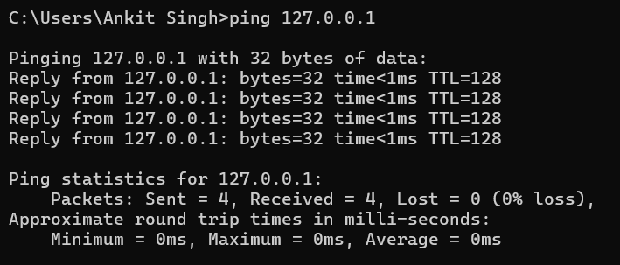
Running ping 127.0.0.1 results in similar output, but with much lower round-trip times since the packets don't leave your machine.

3. Ping Options
- Research and explain the following ping options:
- -c (count)
Limits the number of ping requests sent. ( Valid only for windows )
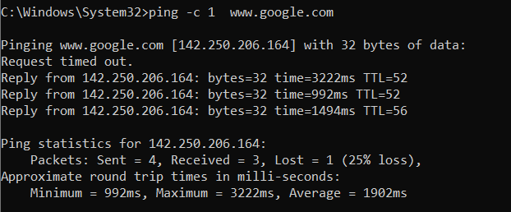
- -s (size)
Specifies the size of the ICMP packets in bytes. (Only for LINUX )
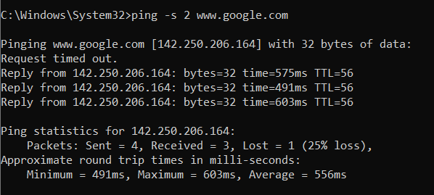
- -t (ttl)
Sets the Time-To-Live for the packets, determining the maximum number of hops. 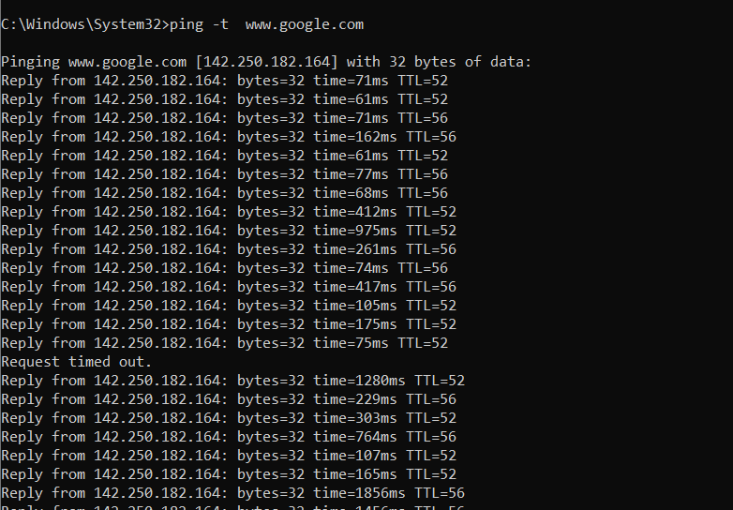

- -W (deadline)
Sets a time limit in seconds for the entire ping command to run.
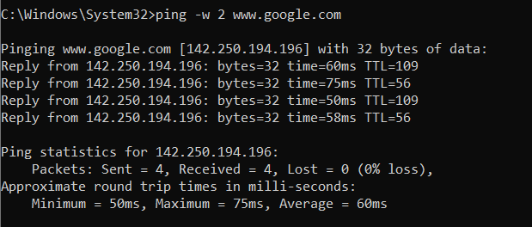

- Provide examples of how to use each option.

4. Troubleshooting with Ping
Imagine a scenario where you are experiencing slow network speeds. You can use ping to determine if the issue lies with your connection to the gateway, a remote server, or the internet.
- ping 127.0.0.1 : If this fails, the issue might be with your local network stack.
- ping 192.168.1.1 : This tests connectivity to your router. If it fails, the issue might be within your local network.
- ping www.google.com : If this fails, the issue might be with your ISP or beyond.
Options to Use:
- -t (TTL): Useful to see if the problem is with reaching a certain hop.
- -W (timeout): To determine if there’s significant delay in responses.
Troubleshooting with Ping
Scenario: Network Slowness
If you're experiencing slow network speeds or connectivity issues, you can use ping to diagnose the problem:

1. Check Basic Connectivity:
- Command:ping google.com
- Purpose: Verifies if you can reach the server and measures round-trip time (RTT).

2. Send Multiple Requests:
- Command: ping google.com -n 10
- Purpose: Provides more data to assess performance consistency over time.

3. Adjust Packet Size:
- Command: ping google.com -l 100
- Purpose: Tests if larger packets cause delays or packet loss, indicating potential issues with packet handling.

4. Change TTL Value:
- Command: ping google.com -i 64
- Purpose:Helps identify routing issues by varying the number of hops packets can take.

5. Set a Timeout:
- Command: ping google.com -w 2000
- Purpose: Determines if responses are delayed or if there are connectivity issues.

Key Indicators:
- Packet Loss: Indicates connectivity problems.
- High RTT: Suggests network congestion or latency.
- TTL Variations: Helps identify routing issues.
- Timeouts : Signals latency or server issues.
5. Develop a ping type utility using Scapy. It should have the following points.
1. Basic Functionality
- Ensure the provided code works correctly.
- Test with different destination IPs and counts.
2. Additional Features
- Implement the following features:
- Option to specify TTL (Time-To-Live)
- Option to specify packet size
- Option to specify timeout
- Use Scapy's built-in functions to implement these features.
3. Error Handling
- Add error handling for cases like:
- Invalid destination IP
- Invalid count or TTL values
- Timeout errors
- Use try-except blocks to catch and handle exceptions.
4. Output Formatting
- Improve the output formatting to include:
- Packet loss percentage
- Average RTT (Round-Trip Time)
- Maximum and minimum RTT values
Output :

Python Code :
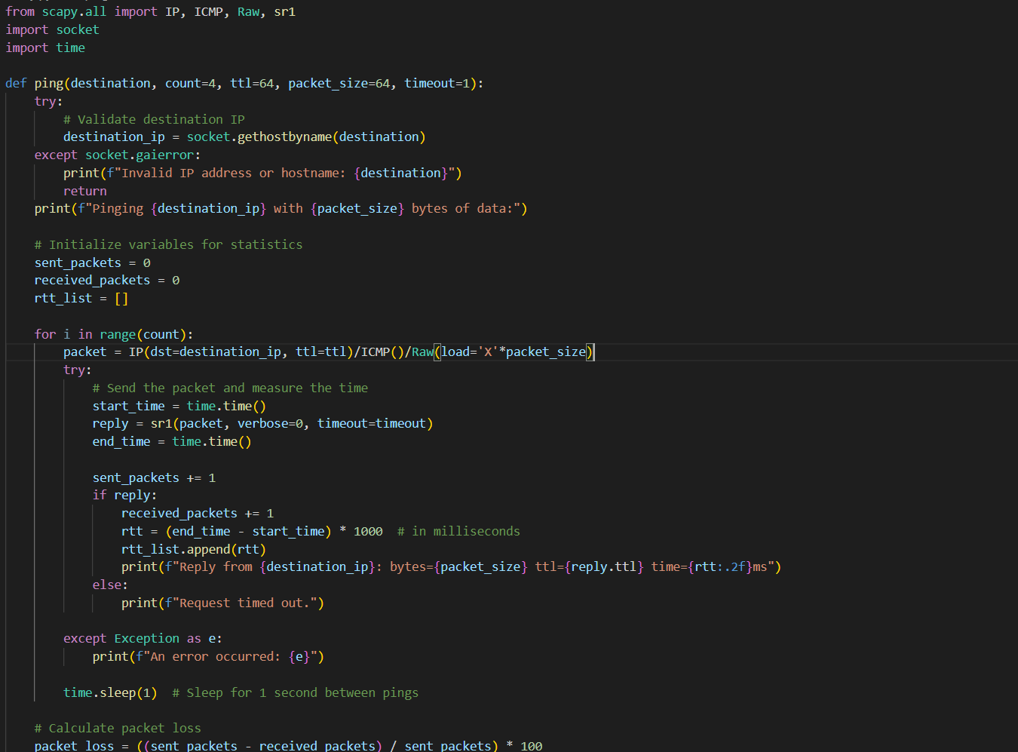
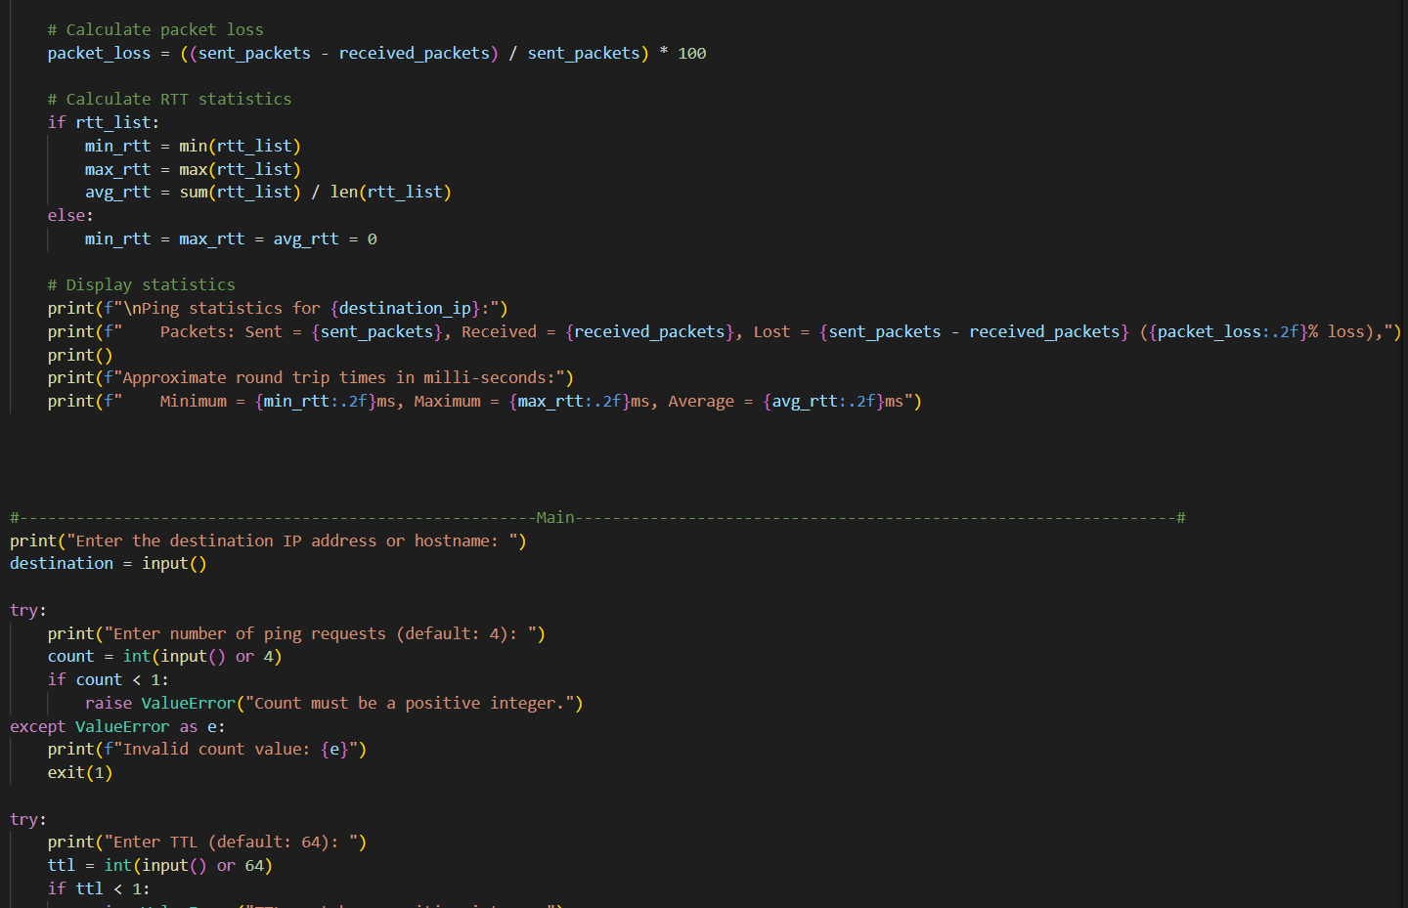
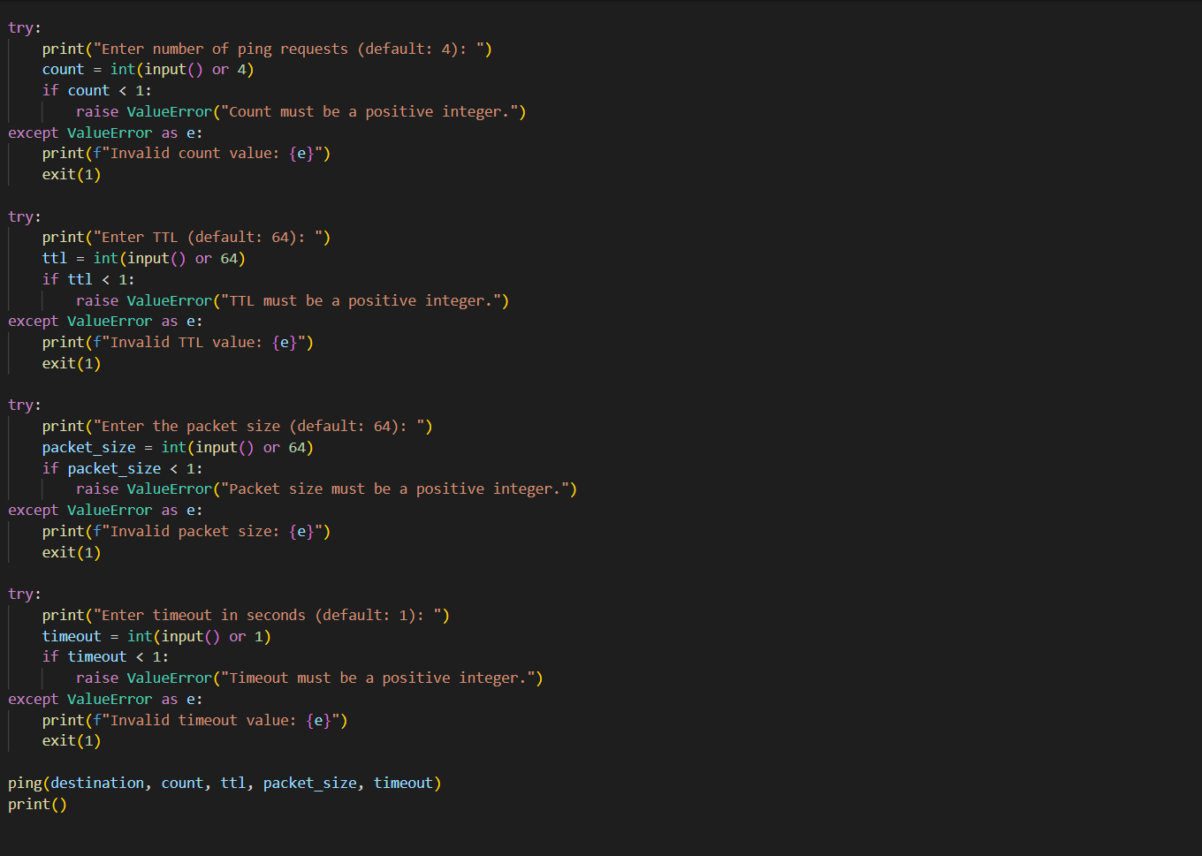
Sample Run 1 :
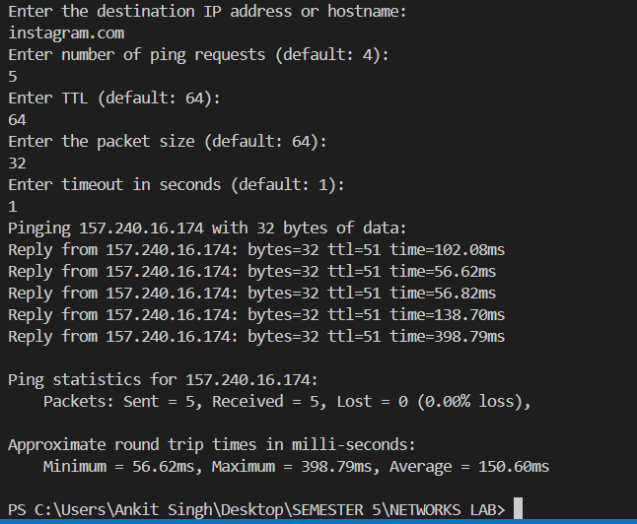

Sample Run 2 :
